
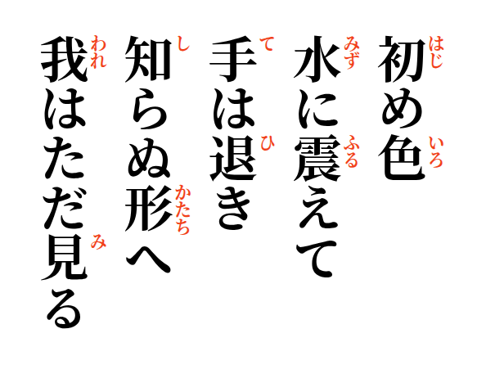
2026-09-01
The first color
trembles in the water—
the hand withdraws,
toward a shape still unknown;
I simply watch.

